- Predicting bond TYPE using ‘Model 1’ of atomic structure

First we need to be clear about the nature of the three main types of bond.

Q: Describe ionic bonding.

A: Ionic bonding is …

Q: Describe a covalent bond.

A: A covalent bond between two atoms is …

Q: Describe metallic bonding.

A: Metallic bonding is …

Q: Using what on Answersheet 1 we called ‘Model 1’ of atomic structure (shell model), on the periodic table below describe and explain the changes that occur i) down a group and ii) across a period and hence predict where you will find pairs of elements / single elements most likely to form i) ionic bonding, ii) covalent bonding and iii) metallic bonding.

A: 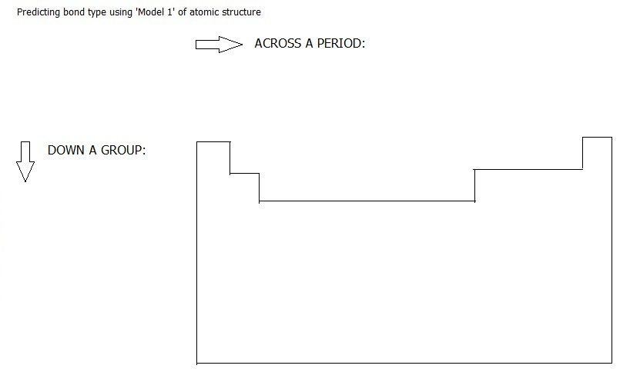

A.1. Intermediate bond types

Q: The three types of bond described so far are extremes. Most bonding is intermediate between two bond types. Between which pairs listed below can intermediate bonding occur:

- Covalent & ionic?
- Covalent & metallic?
- Metallic & ionic?
A:

A.1.i. Covalent vs ionic

Q: In what situations does this apply, elements, compounds or both?

A:

Q: How can it be deduced experimentally whether bonding is predominantly covalent or predominantly ionic?

A:

A1.i.a. Ionic with covalent character

Q: If experiment shows that bonding is predominantly ionic, what factors will lead to a higher degree of covalent character?

Framing the question, we are asking what makes
M^{n+} X^{n-}

tend towards: M---X ?

thus: The degree of covalent character in MX will be greater when M^{n+} is:
- Large or small? A:
- Highly charged or lowly charged? A:

and: The degree of covalent character will be greater when X^{n-} is:
- Large or small? A:
- Highly charged or lowly charged? A:
A1.i.b. Covalent with ionic character

Q: Which pair of elements will be most likely to form a perfect covalent bond, a pair of elements which are close together in the periodic table or a pair of elements which are far apart in the periodic table?

A:

Q: Why?

A:

Q: Why might polar bonds not lead to a polar molecule?

A:

A.1.ii. Covalent vs metallic

Q: In what situations does this apply, elements, compounds or both?

A:

Q: If experiment shows the bonding in a series of elements to be principally covalent, will metallic character increase or decrease:

- Down a group A:
- Across a period A:

Q: If experiment shows the bonding in a series of elements to be principally metallic, will metallic bond strength increase or decrease:

- Down a group A:
- Across a period A:

- Four more types of bonding:

Q: Covalent bonds are on average at least as strong as ionic bonding, if not stronger yet simple covalent compounds have much lower melting points and boiling points than ionic compounds. How?

A:

Q: What are the three main types of intermolecular bonding?

A:

B.1. Permanent dipole – permanent dipole interactions

Q: Describe permanent dipole – permanent dipole bonding.

A:

B.2. Hydrogen bonding

Q: Describe hydrogen bonding.

A:

B.3. Van der Waals or London Dispersion forces

Q: Describe Van der Waals bonding.

A:

B.4. Ion-dipole interactions

As well intermolecular bonding, another type of bonding you need to know about outside the three main types, is ion – dipole bonding.

Q: Describe ion-dipole bonding.

A:

Q: How is it that ionic compounds can dissolve in polar solvents when ion-dipole forces are much weaker than ionic bonding?

A:

- Predicting number of bonds

C.1. Predicting number of ionic bonds

Q: What do we mean by number of ionic bonds, given ionic bonding is non-directional?

A:

C.1.a. Predicting the charge on a positive ion
(Do not be tempted to mention ‘stable octets’ –
see www.chembook.co.uk Chapter 4, section 4.8.2 )

Q: How can the charge on a positive ion be predicted?
Clue: Framing the question: What does the question boil down to?

Why does magnesium form Mg²⁺ and not Mg³⁺?
And why does magnesium form Mg²⁺ and not Mg⁺?

A:

C.1.b. Predicting the charge on a negative ion

Q: How can the charge on a negative ion be predicted?
Clue: Framing the question: What does the question boil down to?

Why does oxygen form O²⁻ and not O³?
And why does oxygen form O²⁻ and not O ⁻?

A:

C.2. Predicting (or at least understanding) number of covalent bonds

Q: Looking at the description of a covalent bond and how it is formed, what do you think gives the first indication of the number of simple covalent bonds an atom of a particular element might form?

For example, looking at the outer electron configuration of nitrogen how many simple covalent bonds would you expect it to form with hydrogens?

N || | | | |

A: Give a general answer then use the example of nitrogen above.

But, there are complications:

C.2.i.

Q: Considering again the description of covalent bonds in the context of ammonia, what might the first complication be?

A:

C.2.ii.

Q: Given carbon’s outer electron configuration, but considering what you know about the number of bonds carbon usually forms, what do you think the second complication might be?

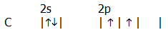

A:

Q: What provides the driving force for the electron promotion?

A:

C.2.iii.

Q: Considering oxygen in NO₂, (bonding and outer electron configuration in the atom) what do you think the third complication might be?

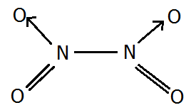

A:

C.2.iv.

Q: Considering the compounds of sulfur, what do you think the fourth complication might be? (Although the two singly occupied orbitals suggest sulphur would form 2 covalent bonds, we know it can form 2, 4 or 6.)

A:

Q: What factors will determine the maximum number of bonds sulfur actually does form with a particular element?
A:

D: Using models 4 and 5 of atomic structure to further describe bonding

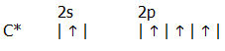

Q: Considering orbital overlap, what problem do you see for the formation of four covalent bonds even when carbon has promoted an electron into the vacant 2p orbital?

A:

Q: However, the shapes of atomic orbitals are a function of their energies, so what do you think might happen to make the orbitals more available for overlap/bonding?

A:

D.1 sp³ hybridisation e.g. in methane

Q: Using ‘Model 4’ of atomic structure (electrons in boxes) describe sp³ hybridisation and using ‘Model 5’ of atomic structure (shapes of orbitals) show how these hybrids form bonds in methane.

A:

D.2 sp² hybridisation e.g. in ethene, buta-1,3-diene and benzene

Q: Using ‘Model 4’ of atomic structure (electrons in boxes) describe sp² hybridisation and using ‘Model 5’ of atomic structure (shapes of orbitals) show how these hybrids form bonds in ethene, buta-1,3-diene and benzene.

A:

D.3 sp¹ hybridisation e.g. in ethyne (outside specification, but included to complete the picture):

Q: Using ‘Model 4’ of atomic structure (electrons in boxes) describe sp³ hybridisation and using ‘Model 5’ of atomic structure (shapes of orbitals) show how these hybrids form bonds in ethyne.

A:

